Topics: Confidence Intervals

- For each of the following statements, indicate whether it is True/False. If false, explain why.

- The sample size of the survey should at least be a fixed percentage of the population size in order to produce representative results.

- The sampling frame is a list of every item that appears in a survey sample, including those that did not respond to questions.

- Larger surveys convey a more accurate impression of the population than smaller surveys.
Answer-
- False- It’s not the percentage of population that matters it is sample size which is important. Ideally sample size should greater than or equal to 30. Because we are not dealing with the entire population. All we are doing is giving our best estimate. If sample we use is unbiased, then estimate is likely to be close to the true value of the population.
- True- Sampling frame is the source material or device from which a sample is drawn. It is a list of all those within a population who can be sampled. survey sampling describes the process of selecting a sample of elements from a target population to conduct a survey.
- True: The larger conveys a more accurate impression of the population as larger surveys involve large sample size which reduces the chances of error.

- PC Magazine asked all of its readers to participate in a survey of their satisfaction with different brands of electronics. In the 2004 survey, which was included in an issue of the magazine that year, more than 9000 readers rated the products on a scale from 1 to 10. The magazine reported that the average rating assigned by 225 readers to a Kodak compact digital camera was 7.5. For this product, identify the following:

- The population
- The parameter of interest
- The sampling frames
- The sample sizes
- The sampling designs
- Any potential sources of bias or other problems with the survey or sample
Answer-
- The population size is 9000 readers who given rating.
- The parameter of interest is customer satisfaction with different brands of electronics.
- The sampling frame is 9000 readers who rated the products.
- The sample size is 225.
- Sample design consists of rating of products on a scale from 1 to 10.
- Sometimes samples don’t give quite a right result. Margin of error depends on the underlying uncertainty, confidence interval and the sample size.

- For each of the following statements, indicate whether it is True/False. If false, explain why.

- If the 95% confidence interval for the average purchase of customers at a department store is $50 to $110, then $100 is a plausible value for the population mean at this level of confidence.

- If the 95% confidence interval for the number of moviegoers who purchase concessions is 30% to 45%, this means that fewer than half of all moviegoers purchase concessions.

- The 95% Confidence-Interval for μ only applies if the sample data are nearly normally distributed.
Answer-
- True- For 95% confidence interval mean is ranging from 50 to $100 and 100 is lying between this range. So, it is a plausible value for the population mean at this level of confidence.

- False- We cannot 100% predict that fewer than half of all moviegoers purchase concession. Because concession range is given in the form of confidence interval, which may not be 100% true.

- False- Because according to central mean theorem, distribution of sample mean will always be normal regardless of distribution of population mean is normal or not. This condition is applicable only when sample size is fairly large. So normal distribution of data set depends on sample size but not on confidence interval.

- What are the chances that ?

- ¼
- ½
- ¾
- 1

Answer- B. The probability of getting a sample mean greater than μ (population mean) is 50%. This is a pure assumption.

- In January 2005, a company that monitors Internet traffic () reported that its sampling revealed that the Mozilla Firefox browser launched in 2004 had grabbed a 4.6% share of the market.

- If the sample were based on 2,000 users, could Microsoft conclude that Mozilla has a less than 5% share of the market?

- WebSideStory claims that its sample includes all the daily Internet users. If that’s the case, then can Microsoft conclude that Mozilla has a less than 5% share of the market?

Answer-
- This is the case of hypothesis testing.
Given- sample size= 2000
Null hypothesis = Mozilla has a less than 5% market share.
Alternate Hypothesis= Mozilla has more than 5% market share.
Finding t-score and probability,

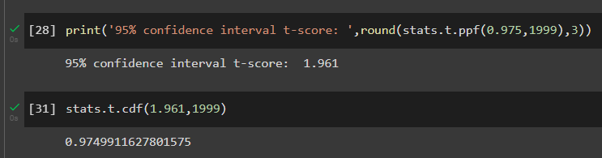

Since P > alpha, we are accepting null hypothesis.
Therefore, Mozilla has a less than 5% share of the market.

- WebSideStory reported that Mozilla Firefox browser grabbed 4.6 % of market share. 4.6% includes all the internet users which is less than 5 %. Hence Microsoft can conclude that Mozilla has a less than 5% share of the market?

- A book publisher monitors the size of shipments of its textbooks to university bookstores. For a sample of texts used at various schools, the 95% confidence interval for the size of the shipment was 250 ± 45 books. Which, if any, of the following interpretations of this interval are correct?

- All shipments are between 205 and 295 books.

- 95% of shipments are between 205 and 295 books.

- The procedure that produced this interval generates ranges that hold the population mean for 95% of samples.

- If we get another sample, then we can be 95% sure that the mean of this second sample is between 205 and 295.

- We can be 95% confident that the range 160 to 340 holds the population mean.

Answer-
A. Incorrect- Range is given in the form of confidence interval, so we cannot 100% predict that all shipments are in given range.

B. Correct-95% of shipments are between 205 and 295 books.

C. Correct-The procedure that produced this interval generates ranges that hold the population mean for 95% of sample.

D. Correct-95% confidence interval indicates that that are 95% chances mean of any sample will fall under given range.

E. Incorrect-The range for 95% confidence interval is 205 and 295.

- Which is shorter: a 95% z-interval or a 95% t-interval for μ if we know that σ =s?

- The z-interval is shorter
- The t-interval is shorter
- Both are equal
- We cannot say
Answer-
B. The t-interval is shorter.
Because Research has shown that the t-distribution is fairly robust to deviation of the population from the normal model.

Questions 8 and 9 are based on the following: To prepare a report on the economy, analysts need to estimate the percentage of businesses that plan to hire additional employees in the next 60 days.

- How many randomly selected employers (minimum number) must we contact in order to guarantee a margin of error of no more than 4% (at 95% confidence)?

- 600
- 400
- 550
- 1000
Answer-
Since standard deviation is not given in this numerical, we need to solve is using formula given below,
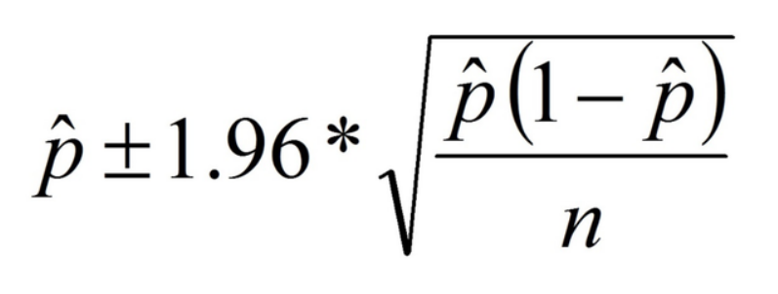

Where p-hat represents predicted probability of approval. This value should be maximum in order to get accurate sample size.
P-hat | (1-p-hat) | p-hat(1-p-hat)
1 | 0 | 0
0.9 | 0.1 | 0.09
0.7 | 0.3 | 0.21
0.5 | 0.5 | 0.25
0.4 | 0.6 | 0.24
0.2 | 0.8 | 0.16
0.3 | 0.7 | 0.21

From above table we can understand that 0.5 will give us maximum value.
n = 1.96²*0.25/0.04² = 600.25 ≈600
Therefore 600 randomly selected employers we must contact in order to guarantee a margin of error of no more than 4%.

- Suppose we want the above margin of error to be based on a 98% confidence level. What sample size (minimum) must we now use?

- 1000
- 757
- 848
- 543

Answer-
Finding z-score for 98% confidence interval,
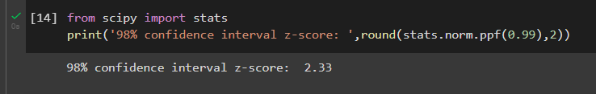

Substituting z score in the formula,
n = 2.33²*0.25/0.04² = 848.26≈ 848
Therefore sample size for 98% confidence interval is 848.

